**NOTICE OF RACE**

**2023 CHINA WEIHAI HOBIE OPEN REGATTA**

Weihai City is scheduled to host the China Weihai HOBIE Open Regatta from June 10th-11th, 2023. The regulations of the competition are hereby announced as follows:

1. **Name**

2023 HOBIE Open Regatta (Weihai, China)

1. **Date**

June 10th-11th, 2023.

1. **Organizers**

**Hosted by:**

International HOBIE Class Association (IHCA),

Chinese Yachting Association,

Shandong Province Administration of Sports,

Weihai Major Sports Events Organizing Committee

**Organized by:**

Weihai Municipal Sports Bureau,

Administrative Committee of Weihai Torch Hi-Tech Industrial Development Zone

1. **Venue**

International Bathing Beach, Weihai City, Shandong Province, China.

The reference coordinates of the racing area:

(1) N 37°33.738，E 122°00.309;

(2) N 37°31.889，E 122°01.318;

(3) N 37°34.054，E 122°01.251;

(4) N 37°32.217，E 122°02.415.

1. **Number of boats**

The Local Organizing Committee (LOC) will provide 30 HOBIE-16 sailboats; the LOC can also rent 5 boats on behalf of the boats’ owners; Participants can bring their own boats.

1. **Class**

The regatta shall be categorized into 2 Classes: Masters Class, Open Class.

1. **Eligibility**

**7.1** The regatta is open to HOBIE sailing athletes and amateurs who respect China’s national sovereignty and abide by China’s current laws, regulations and customs, as well as having legal nationality and identification.

**7.2** Athletes shall be in good health conditions, have the physical conditions to participate in the HOBIE regatta, and voluntarily assume all adverse consequences and legal responsibilities resulting from concealing their physical conditions or incorrectly assessing their physical conditions for participation. We kindly reject people who are unwell or infected with strong infectious virus to participate in this competition.

**7.3** Sailing competition has certain risks. Athletes should fully understand the risks that may be faced by participating in water sports, especially sailing, and voluntarily bear the risks. Athletes must constantly monitor their physical condition. In case of acute disease before the competition, athletes should immediately take the initiative to give up the competition; in case of chest tightness, chest pain, panic, nausea, dyspnea, abnormal fatigue and other conditions during the competition, stop the competition immediately and seek help from the nearest medical point or staff. According to Article 4 of the world Sailing Federation competition rules, the contestants shall bear personal injuries and financial losses before, during and after the competition. The competition organizing committee shall not be liable for the above injuries and losses caused by the contestants' personal reasons.

**7.4** The paying members of IHCA have priority registration. The non-registered members must provide the supporting materials for the entry or completion of other HOBIE events or obtain the approval of the LOC.

**7.5** The Helmsmen of the Masters Class must be at least 45 years old.

1. **Rules**
   1. **Execute rules.**

The regatta shall follow the rules as defined in the Racing Rules of Sailing (RRS) and IHCA Class Rules. In case of any ambiguity in the translation, the Chinese version shall take precedence.

* 1. **Referee.**

The regatta shall hire international and national referees who meet the international competition standards to rule the competition.

* 1. **Advertisements.**

The sailboats shall display the advertisements of the LOC. Participants are prohibited to exhibit their own advertisements through various channels. If there is a demand, participants must consult with the LOC and obtain written consent.

* 1. **Regatta sailboat check.**

During the competition, the sailboats may be checked at any time, and each boat should comply with IHCA Class Rules.

* 1. **Sailing Instruction.**

Sailing Instruction will be released and issued during Captains’ Meeting.

* 1. **Sailing course.**

The attachment shows the course. The course will be released at Captains’ Meeting.

* 1. **Scoring.**

Execute Low Scoring Method (Appendix A in RRS). Score will come into effect after each race is completed. When fewer than four races are completed, the total race score of the boat shall be the boat’s final score; if more than five (including five) races are completed, the worst round’s score will not be calculated, and the final score will be the sum of the rest rounds.

* 1. **Security Boats.**

Support boats shall be marked with “H’® flag.

* 1. **Wireless communication.**

Except for emergencies, the regatta sailboats shall not send and receive voice or data transmissions other than the voice or data transmissions sent uniformly to the regatta sailboats.

* 1. **Event insurance.**

In view of the risk factors existing in the competition, it is recommended that participants purchase professional sports competition insurance with valid third-party liability insurance, covering the regatta period and area by themselves, with the hospitalization medical insurance compensation amount no less than 80,000 CNY and death insurance compensation amount no less than 900,000 CNY. The LOC will purchase the Public Liability Insurance for the participants, without extra charge.

* 1. **Safety suggestions.**

It is recommended to use a hookless suspender device that conforms to the ISO10862 standard or a quick-release suspender and hook cable. It is recommended to use the helmet that conforms to the European standard EN1385.

* 1. **Balance weight arrangement.**

participants are required to bring their own weights and auxiliary equipment such as lead blocks. Rules require all classes to weigh no less than 285 pounds (129.3kg).

* 1. **Penalty.**

For the HOBIE 16 class RRS 44 is changed so that the Two-Turn Penalty is replaced by the One-Turn Penalty. Decisions of the international jury will be final as provided in RRS 70.5.

* 1. **Dispute Resolution.**

If there is any dispute about the referee's punishment or competition scores, the participants or his/her team leader shall submit a written statement or arbitration to the referee within 30 minutes after the end of the games. No more appeals and arbitration will be accepted 30 minutes after the end of the games. After verification, if there is improper religious or political behavior, or if there is improper way to file a claim and take an improper form that cause bad social impacts, the involved should be dealt according to Opinions on Further Regulating the Behaviors of Sports Arenas by the General Administration of Sport of China (2018, No. 9) and included in the personal credit report. Anyone who violates the law shall be investigated according to law.

* 1. Due to uncontrollable factors such as earthquakes, storms, safety, disease, etc., the LOC may issue other regulations related to the competition until the competition is cancelled. The LOC declares that it will not bear any legal responsibility arising therefrom.

1. **Reward systems**
   1. **Open Class**

The top 8 winners will be awarded 80,000CNY in total. Prizes will be given as follows:

|  |  |  |  |
| --- | --- | --- | --- |
| **RANK** | **AWARD** | **RANK** | **AWARD** |
| Winner | 20,000 CNY | 5th Place | 8,000 CNY |
| 2nd Place | 16,000 CNY | 6th Place | 6,000 CNY |
| 3rd Place | 14,000 CNY | 7th Place | 4,000 CNY |
| 4th Place | 10,000 CNY | 8th Place | 2,000 CNY |

If the registered teams are less than or equal to 10 teams (6-10 teams), the admission ranking will be reduced by 3.

If the number of registered teams is less than or equal to 5 (4-5 teams), only the first place will be admitted.

If the number of registered teams is less than or equal to 3, no ranking will be accepted.

The above prizes are pre-tax bonuses.

* 1. The top three winners in the Master group will receive no prize money.
  2. All ranking prizes will be awarded with trophies.

1. **Schedule**

The race will be announced later. There will be no preview signal after 15:00 June 11th.

|  |  |  |  |  |
| --- | --- | --- | --- | --- |
| **NO** | **Date** | **Time** | **Location** | **Details** |
| 1 | June  8th | Before 12:00 | Weihai Facing Sea Hotel | Referees’ Registration |
| 2 | June  9th | Before 13:00 | Weihai Facing Sea Hotel | Registration |
| 3 | 13:00-15:30 | Weihai International Beach | Sailboats and Racing Site Visiting |
| 4 | 16:30-17:30 | Weihai Facing Sea Hotel | Captains’ Meeting |
| 5 | June  10th | Before 8:10 | Weihai International Beach | Sails Raising and Lining up |
| 6 | 8:30 | Weihai International Beach | Opening Ceremony |
| 7 | 9:00-17:00 | Weihai International Beach | Race |
| 8 | June  11th | 9:00-16:00 | Weihai International Beach | Race |
| 9 | 18:30-20:30 | Weihai International Beach | Awards Ceremony |

1. **Fee Description**
   1. **Entry fee**

1000 CNY entry fee per team (up to 2 classes of competition)

* 1. **Charter fee**

1000 CNY per sailboat. The LOC will transfer the charter fee to the boat owners.

The LOC shall charge a separate deposit of 2,000 CNY for each sailboat at the registration site. If the leased vessel or important parts are damaged, the leased team shall compensate at the market price.

* 1. **Transportation expense.**

The transportation expense shall be borne by the participants.

* 1. **Accommodation expenses**

1) The LOC shall provide free accommodation from June 9th to 11th for the top 3 teams in all previous HOBIE World Championship and the winner teams in all previous Asian Games HOBIE sailing races. The teams shall cover the accommodation at their own expenses if over the stipulated time.

2) Accommodation booking information will be provided before June 1st, and the LOC will assist in providing preferential accommodation: 300 CNY/day for standard room, 320 CNY/day for double bed room and 580 CNY/day for business suite. The room rate includes breakfast for two people, and check out before 2 PM. Hotel buffet 50 CNY/person standard.

3) Lunch during the competition and dinner at the award party will be borne by the LOC.

* 1. **Preferential policies.**

Entry fees and Sailboat charter fees will be waived for the top 3 teams in all previous HOBIE World Championship and the winners in all previous China Weihai HOBIE Open Regatta.

If the event sponsor forms a team, the registration fee and charter fee will be waived according to the amount of sponsorship.

* 1. **Payment**

The entry fee and charter fee shall be paid to the account designated by the LOC by telegraphic transfer or bank transfer.

Account Name: 威海市帆船协会

Weihai Sailing Association

Bank Name: 中国银行股份有限公司威海分行文化名居分理处

Bank of China Limited Weihai Branch Wenhua Mingju Sub-branch Office

Account Number: 228613271562

Please note "×× and ×× entry and charter fee" when transferring or telegraphic transfer, and call +86-631-5127389 to confirm after payment.

1. **Entry and Registration**
   1. **Entry.**

1) All participants shall complete entry before May 19th. The successful entry shall be confirmed by the LOC.

2) All participants shall sent the entry form to the email address, and call Mr. Xia Dongxiao (tel: +86-13666307719) to confirm the entry information. Need more help, please contact +86-631-5817333 .

* 1. **Registration**

All participants must complete registration before 13:00 on June 9th.

**Place:** Weihai Facing Sea Hotel

**Address:** No. 22, Shanghai Garden (Intersection of Torch Eight Street and Huanhai Road), High-tech District, Weihai City, Shandong Province. Tel: +86-631-6177999

**Contact:** Mr. Dongxiao Xia.

Tel: +86-13666307719.

1. **China Weihai HOBIE Open Regatta will be held on the second weekend of June every year. Please pay attention and make the make arrangements for the regatta in advance.**
2. **The unmentioned issues shall be formally notified by the LOC.**

**Annex:**

1.Race Map

2.Entry form

Weihai Major Sports Events Organizing Committee

10 April, 2023

**Annex 1**

**Race Map**

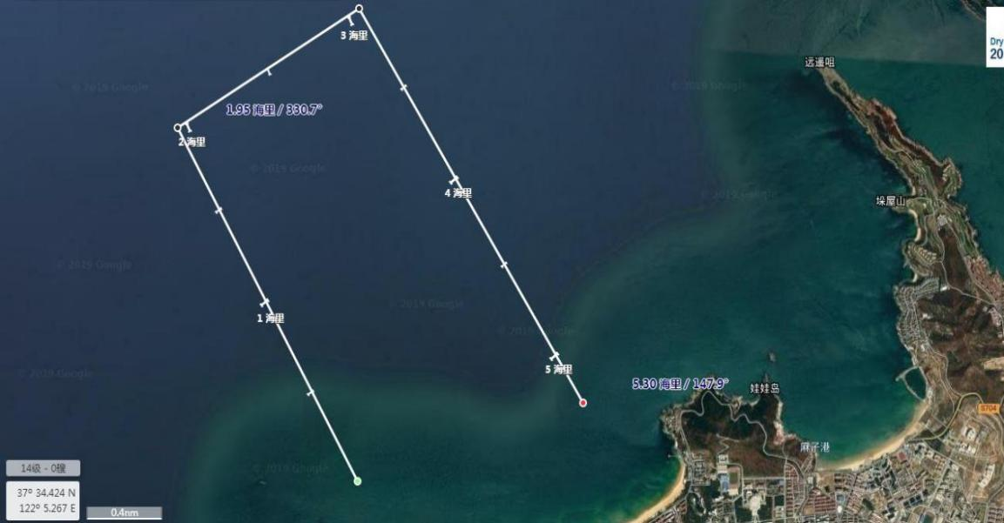

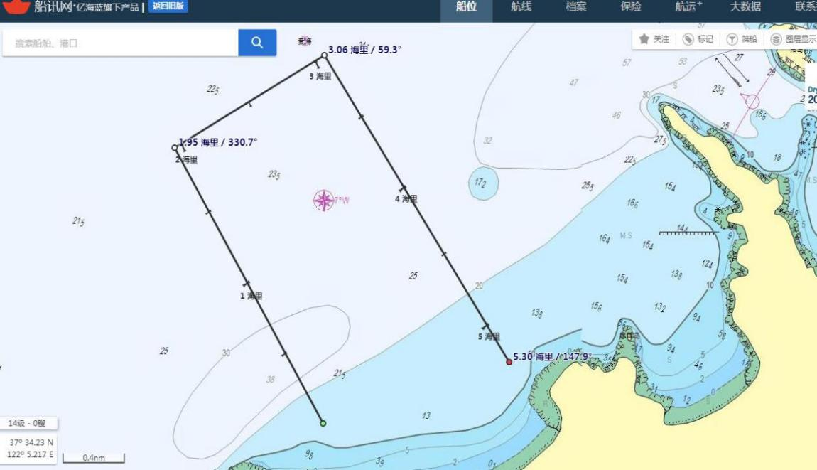

[Reference](javascript:;) c[oordinate](javascript:;)

1. N 37°33.738 3. N 37°34.054

E 122°00.309 E 122°01.251

1. N 37°31.889 4. N 37°32.217

E 122°01.318 E 122°02.415

(Note: Long voyage experience course will be released separately during the captain's meeting)

**Annex 2**

**Team Entry Form**

|  |  |  |  |  |  |  |
| --- | --- | --- | --- | --- | --- | --- |
| Class |  | | | Sailboat | 🞎Rent/🞎Bring own boat | |
| Position | Skipper | Name | |  | Gender |  |
| Nationality |  | Date of Birth  (yyyy/mm/dd) | |  | Weight | KG |
| Certificate Type |  | | | ID Number |  | |
| Healthy Condition |  | | Description | *(Fill in blood type, allergy history or other important information)* | | |
| Working Organization & Position |  | | | E-mail |  | |
| Phone Number |  | | | Emergency Contact Person&  Phone number |  | |
| Race experience and results: | | | | | | |
| Position | Trimmer | Name | |  | Gender |  |
| Nationality |  | Date of Birth  (yyyy/mm/dd) | |  | Weight | KG |
| Certificate Type |  | | | ID Number |  | |
| Healthy Condition |  | | Description | *(Fill in blood type, allergy history or other important information)* | | |
| Working Organization & Position |  | | | E-mail |  | |
| Phone Number |  | | | Emergency Contact Person&  Phone number |  | |
| Race experience and results: | | | | | | |
| Other Information | | | | | | |
| Arrival Date&Time |  | Arrival  Airport/Station | |  | Arrival  Flight/Rail NO. |  |
| Departure Date&Time |  | Departure Airport/Station | |  | Departure Flight/Rail NO. |  |
| Room  Type&Number |  | Check-in  Date&Time | |  | Check-out  Date&Time |  |